Level 1 1
Level 2 1
Level 3 1
Level 4 1
Level 5 1

Level 1
We created a plane called Ground, centered at the origin (Transform X, Y, Z = 0), and scaled it up to serve as the floor. We organized the materials into a Materials folder, created a colored material, and assigned it to the Ground. We built four resized cubes to form walls around the Ground, assigned them an appropriate material, and grouped them into an empty GameObject called Walls (Fig. 1).

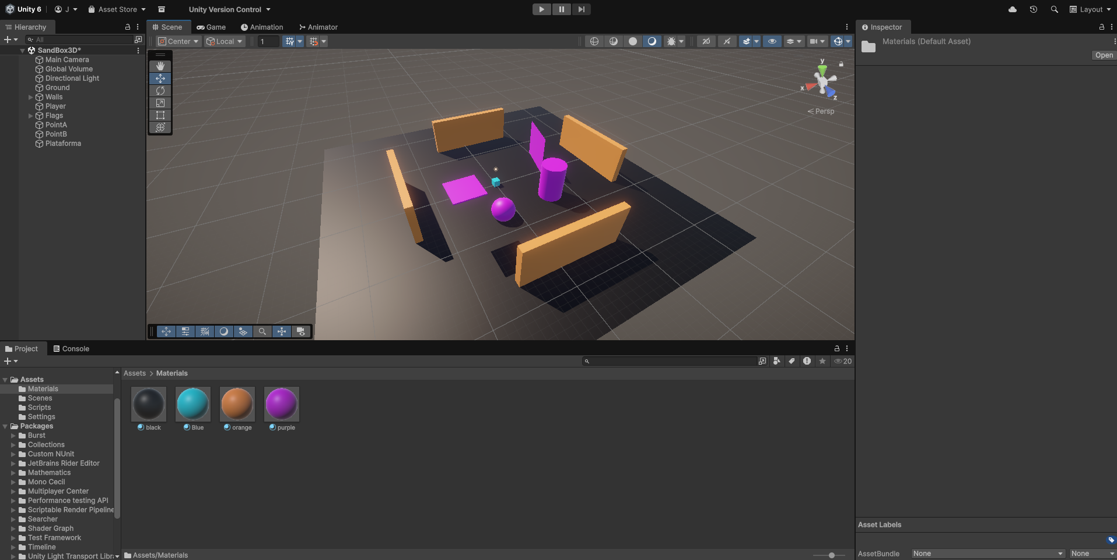
Fig.1

Level 2
We created a Player GameObject with Rigidbody physics, set the ‘Player’ tag, and applied constraints in the Rigidbody to prevent abnormal behavior. We implemented the PlayerController script and attached it to the Player. In the script, we defined a speed variable (Fig. 2), a private MovePlayer method called in Update, and inside this method we calculated the movement values to make the Player move based on input, time, and speed, using transform.Translate. We also added a public integer variable points to the script and linked it to the Player.
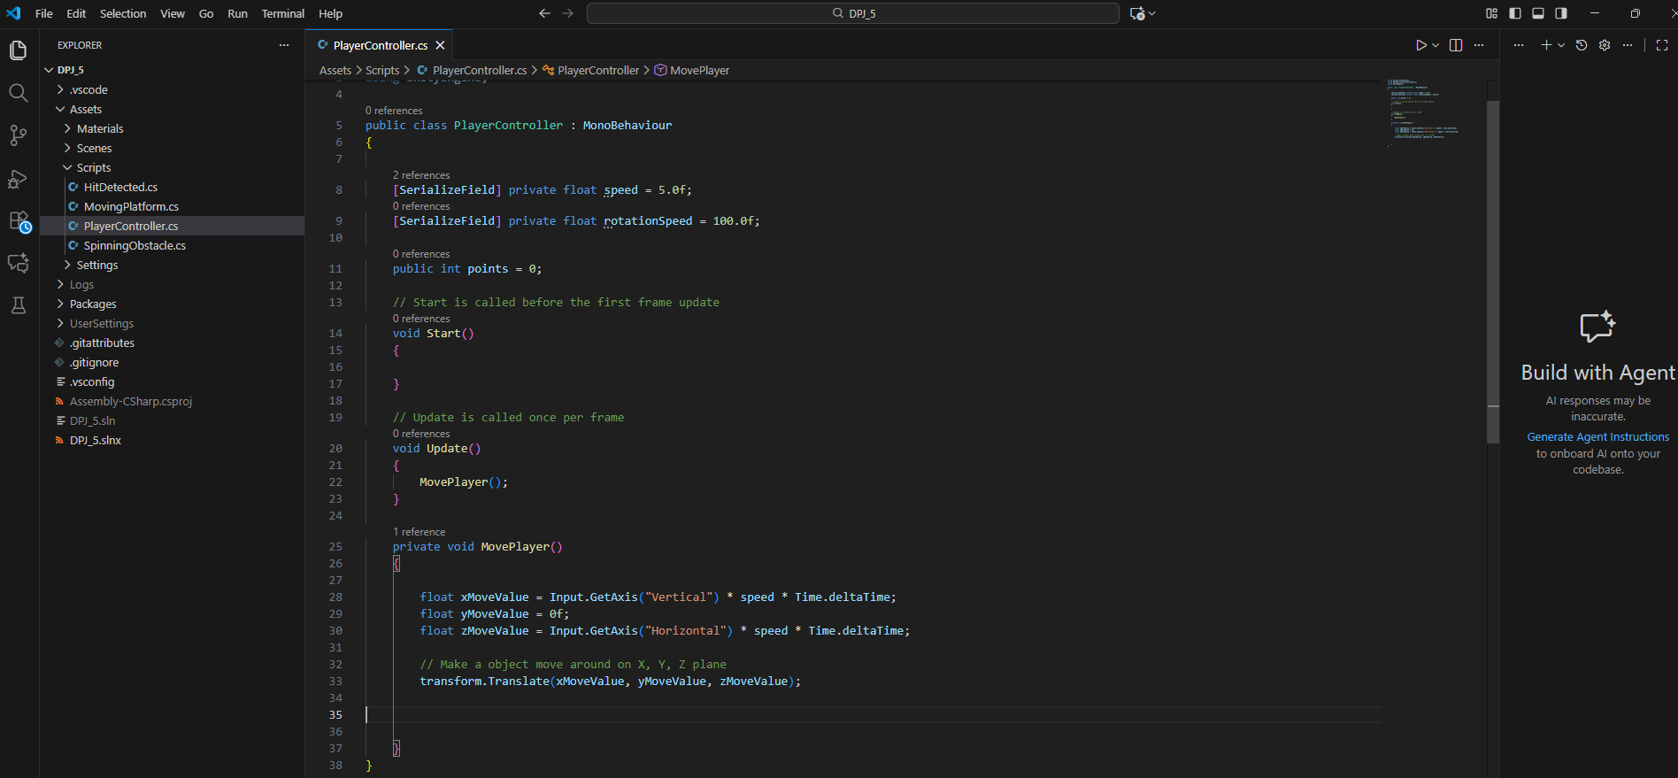
Fig.2

Level 3
We created the HitDetected script, containing only OnCollisionEnter (Fig. 3). This method checks whether the object that collided has the ‘Player’ tag and, if so, changes the color of the collided object (Fig. 4). The GameObjects that receive this script should have the Collided tag. We created several GameObjects named Flag, distributed around the scene for the player to collide with.
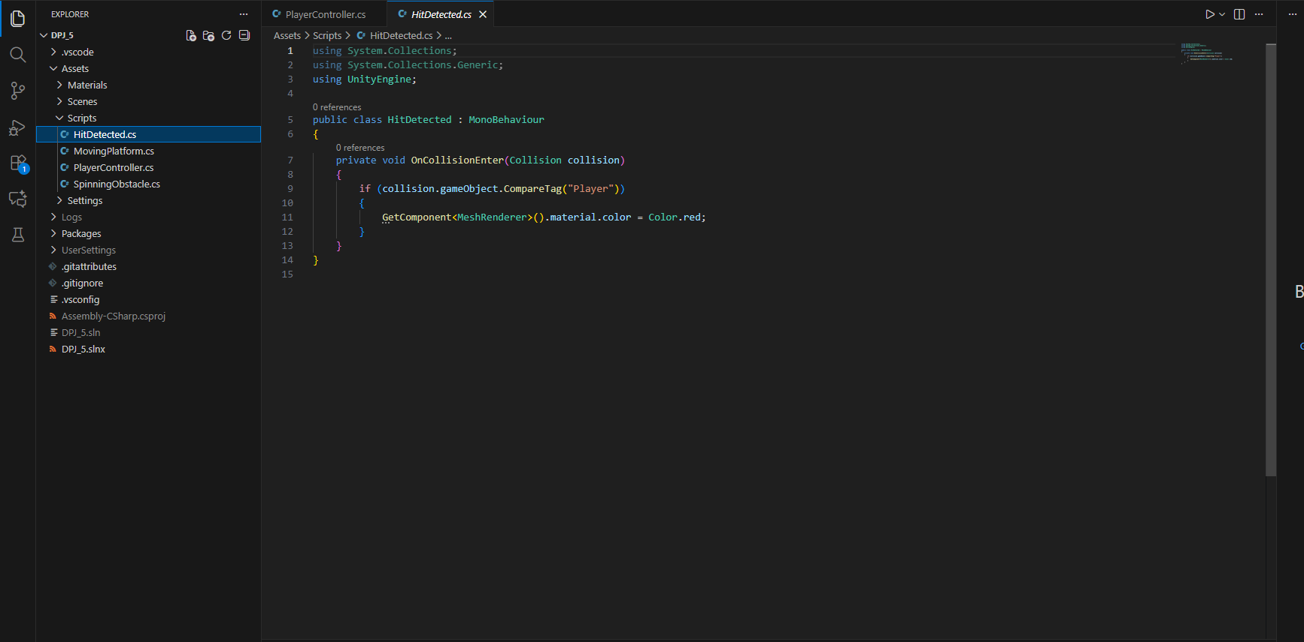
Fig.3

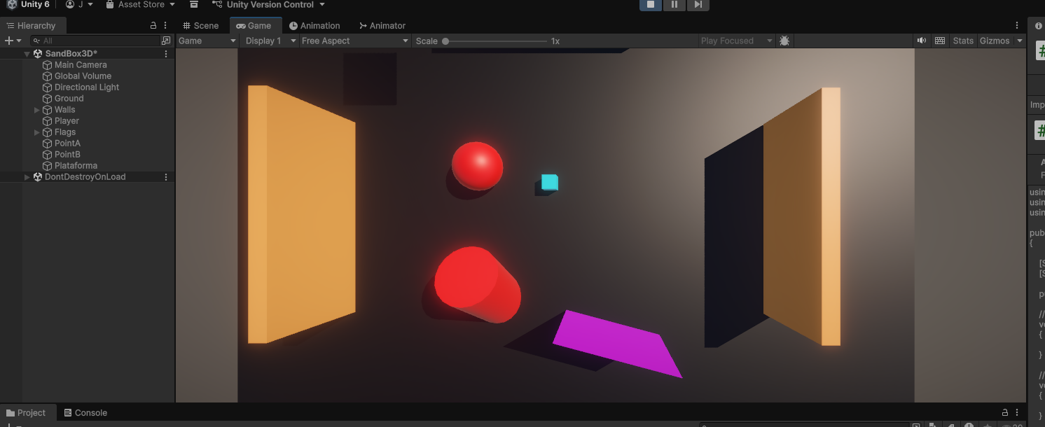
Fig.4

Level 4
We implemented the SpinningObstacle script with three float variables (xAngle, yAngle, zAngle), editable in the inspector, and applied transform.Rotate() in Update to rotate the object. We created the MovingPlatform script with references to two Transforms (PointA and PointB), variables waitingTime, movingSpeed, and internal states (targetPoint, waitTimer, isWaiting). In Start we initialized values, and in Update we controlled the movement with Vector3.MoveTowards between PointA and PointB. For each platform, we created two empty GameObjects (PointA and PointB) positioned at the desired stopping points (Fig. 5).

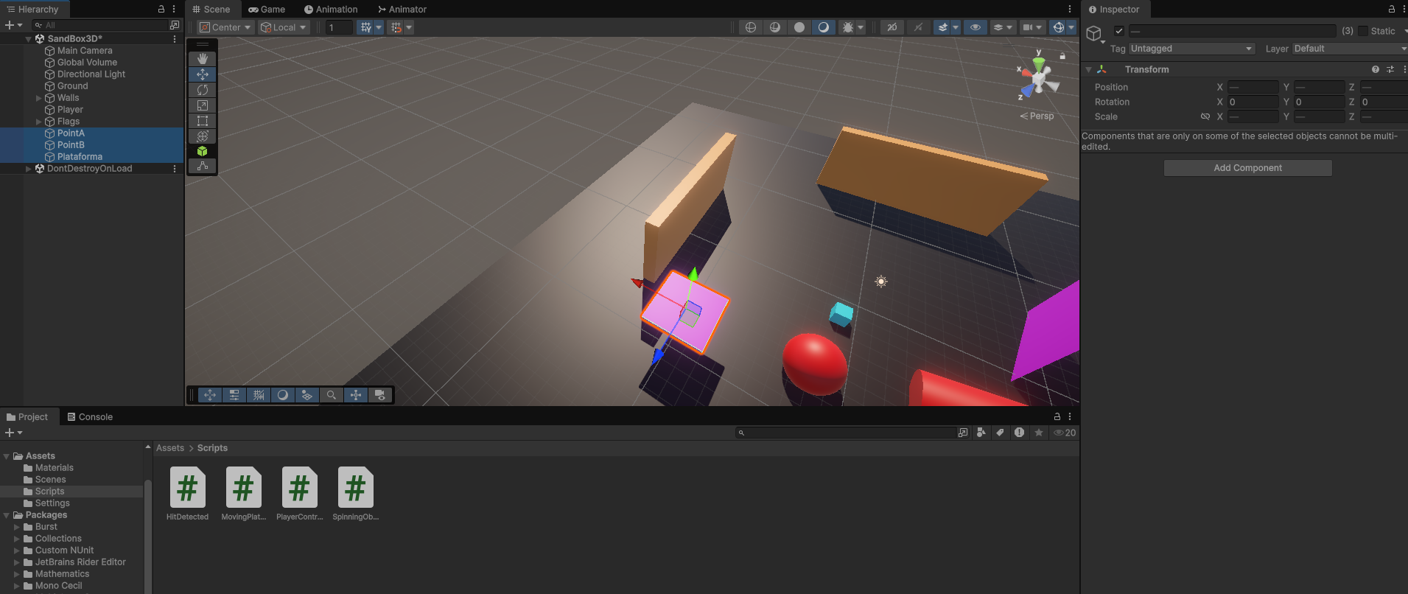
Fig.5

Level 5
We assigned the SpinningObstacle and MovingPlatform scripts to the intended GameObjects and connected the PointA/PointB Transforms on the platforms.

